# Problem Statement

A vending machine has a finite number of states where at one point the machine is in one particular state. Progression to the next state happens once the input has been accepted by the machine but at this point, the number of states is has, hasn't been yet validated.

# Planning

For this assessment we used WhatsApp from the 31st March for communication amongst the group and this was done by Nothando Ngwenya.

Our group consists of ten students but only seven participated.

Our first discussion was more of an introduction and on what the assessment was about. A GitHub repository was created that day by Werner Pieters and he added everyone that produced their credentials on the group until 19th April; he also started working on the FMS diagram for the vending machine.

On the 2nd April, we decided to resume after recess. On the 12th April we had a contact meeting with a few of our group members – M Nota, Werna Pieters, Nothando Ngwenya and Tlhogi Peete to discuss who was going to do what. We decided that M Nota and Nothando Ngwenya were to do the documentation, Werner Pieters and Tlhogi were to do the FMS and clips code. Nothando Ngwenya wrote the problem statement and added it to the repository on the 13th April.

On the 15th of April Werner was still working on the FMS diagram and this is what he was able to do and he also added it to the repository.

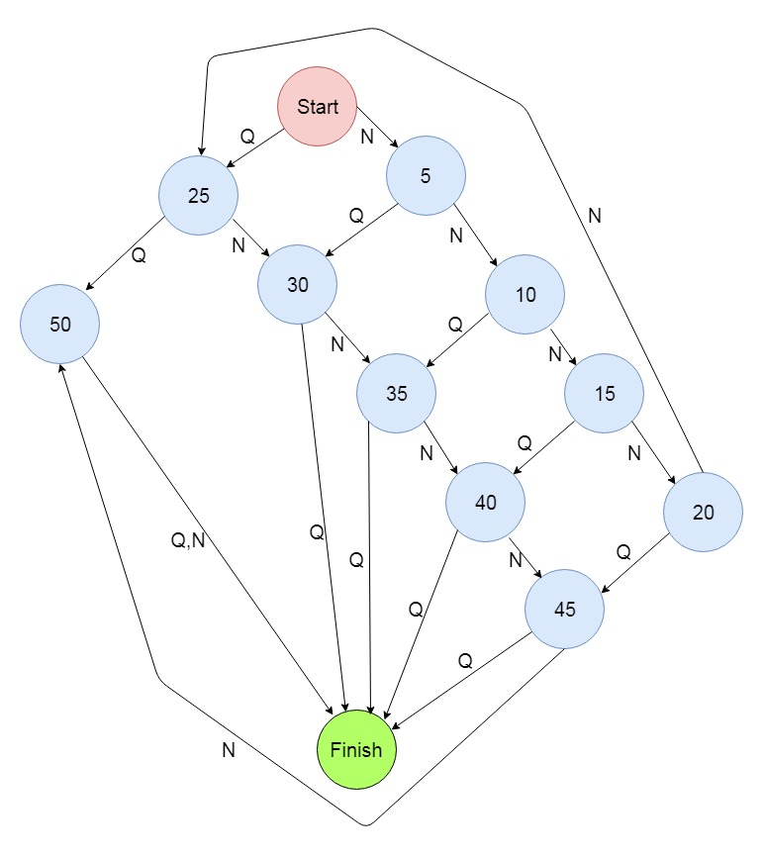

FMS Diagram for Vending Machine.

We further discussed the proceedings for the clips code and how to approach and divide the work amongst ourselves. Werner, Nothando, Tlhogi and M Nota were involved in this discussion on WhatsApp.

Werner submitted the GitHub repository link on efundi on the 16th April.

On the 9th and 12th May, Sumi, Werna and Tlhogi discussed when our next contact meeting should be and the improvements needed for the FMS to implement other coins for the vending machine.

On the 13th May Thlogi and Werner uploaded the clips code for the vending machine and decided to use Tlhogi’s as our final code.

On the 14th May, Nothando did the documentation and M Nota decided to add code to the repository.

**Our GitHub Repository**

https://github.com/DarkS1D3R/ITRW-313-Group-9/

# User Guide

* Make sure you have clips installed on your computer in order to run the application. Here’s a link to download - <https://sourceforge.net/projects/clipsrules/?source=typ_redirect/>.
* Once installed, click on “Environment” and “Load Constructs” then select the file to load.
* Click on “Debug” and select “Agenda Browser" then click on “Reset” then “Run”. You should see a question displayed and then enter one of the item numbers to make a selection of what you want to purchase.
* Once you have entered the item number, a list of prices will be displayed and you will be required to enter the amount you want to use to purchase exactly as indicated. You will be asked to select the amount until (provided it is still short) you have paid the required amount.
* Once the amount is fully paid, a message will let you know how much change you have provided your last entered amount was more.